TEST CASE

SERVICE NAME- Application for Issuance of Age Certificate - GP

DATE-28/07/2020

NAME OF TESTER-Avinash Rana

1. TEST CASE FOR APPLICATION FORM

ALLOWED DATA CATEGORY

1. CHARACTER
2. NUMBER
3. EMAIL
4. MOBILE NUMBER
5. COMMA,/,_ ,-
6. Keyword like-insert,update,script,js,javascript,java,php,delete

|  |  |  |  |  |  |  |
| --- | --- | --- | --- | --- | --- | --- |
| S.NO | TEXT BOX/AREA  Name | Allowed Data Category | Special character allowed(Y/N)If yes then specify the special character | Category F allowed(Y/N) | Test case passed(Y/N) | Remark |
| 1 | Applicant name | A | N | N | Y | - |
| 2 | Name of applicant's father | A | N | Y | Y | - |
| 3 | Name of applicant's husband | A | N | Y | Y | - |
| 4 | Name of the Village | A,B | Y | N | Y | - |
| 5 | Post Office | A,B | Y | N | Y | - |
| 6 | Present place of residence | A,B,E | Y | N | Y | - |
|  |  |  |  |  |  |  |

2.Test case for service

|  |  |  |  |  |  |  |
| --- | --- | --- | --- | --- | --- | --- |
| S.NO | APP_REF_NO | SEX | GUARDIAN | DATA FROM FORM MATCHED WITH CERTIFICATE(Y/N) | Test case passed(Y/N) | Remark |
| 1 | AIAC-GP/2020/00029 | MALE | FATHER | Y | Y | - |
| 2 | AIAC-GP/2020/00030 | FEMALE | HUSBAND | Y | Y | - |
| 3 | AIAC-GP/2020/00029 | FEMALE | FATHER | Y | Y | - |

3.TEST CASE FOR REJECTION APPLICATION

|  |  |  |  |  |  |
| --- | --- | --- | --- | --- | --- |
| S.NO | APP_REF_NO | SEX | APPLICATION CLOSED AFTER REJECTION(Y/N) | Test case passed(Y/N) | Remark |
| 1 | AIAC-GP/2020/00031 | MALE | Y | Y | - |
| 2 | AIAC-GP/2020/00032 | FEMALE | Y | Y | - |

4. Screenshot of Application Form

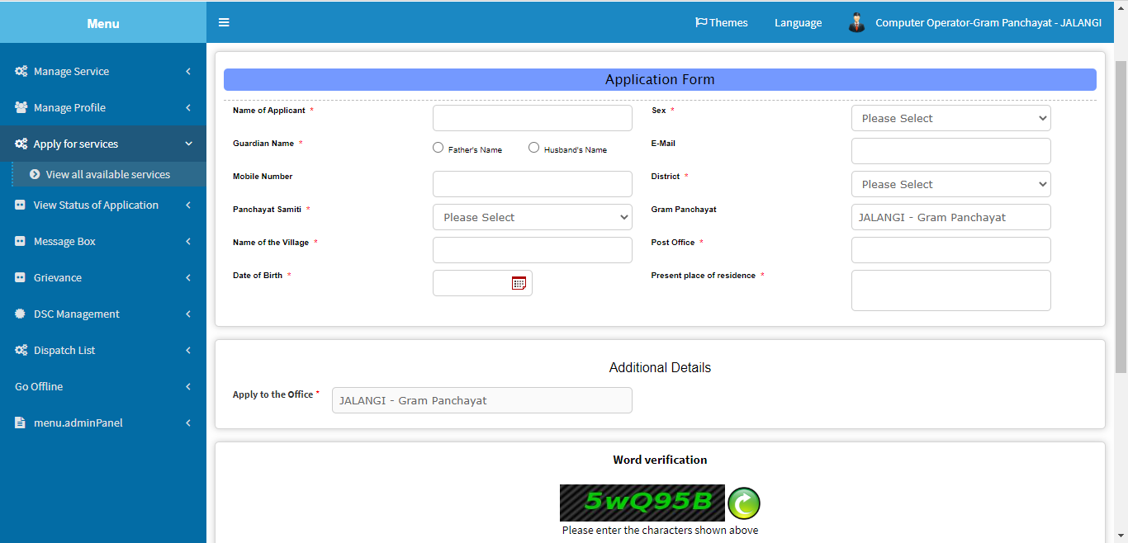

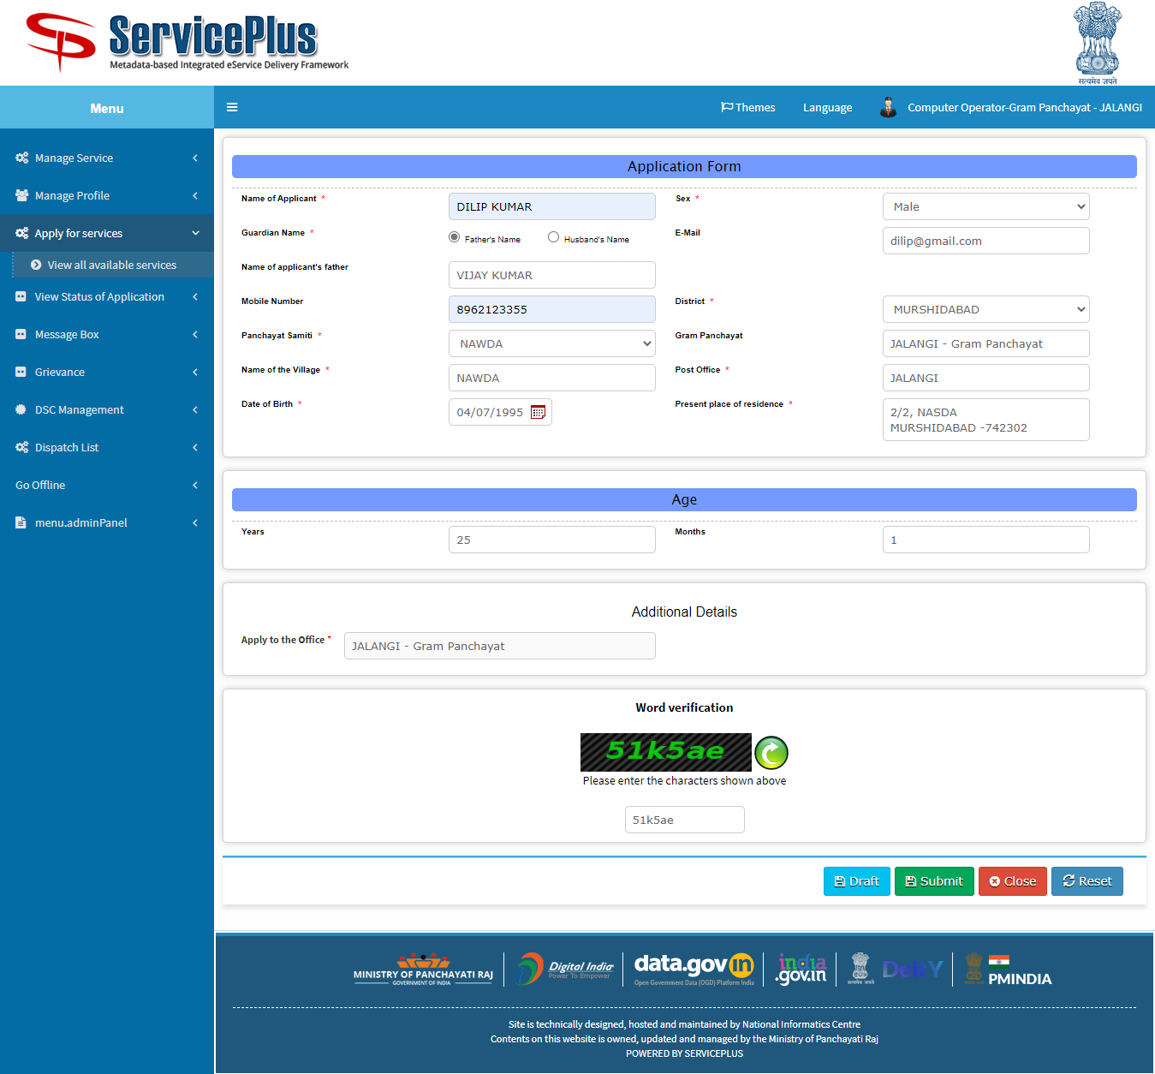

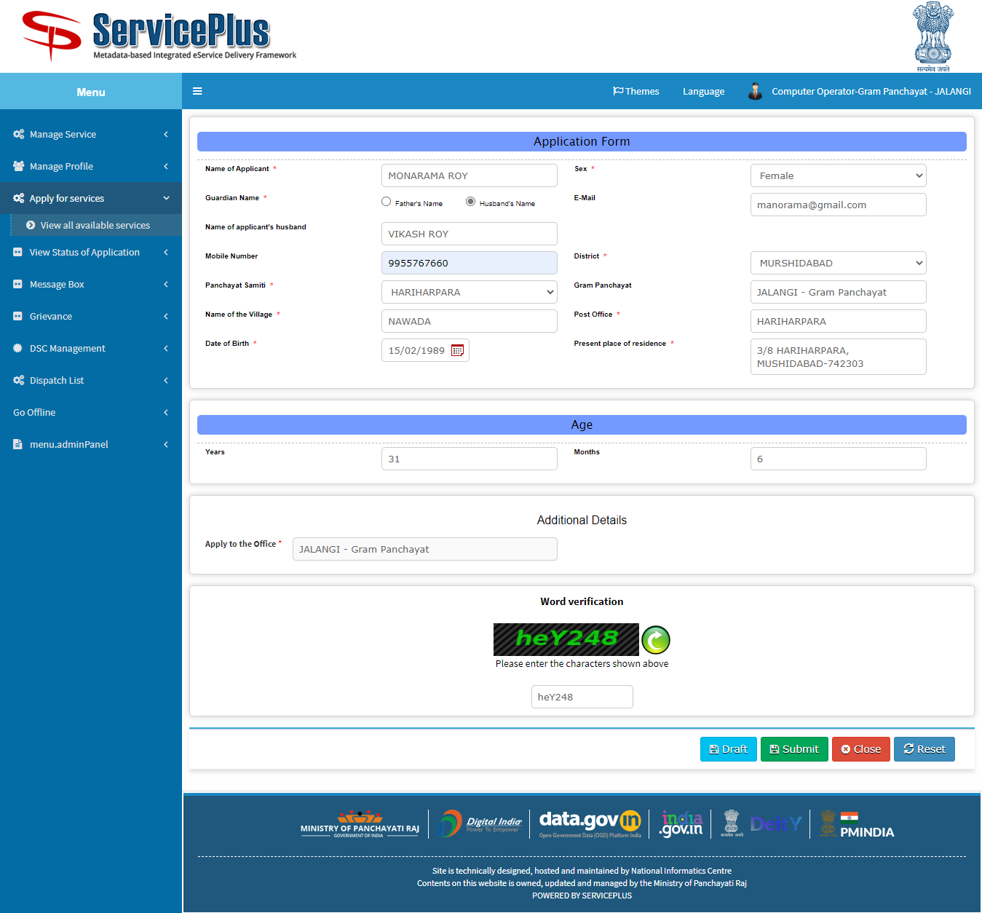

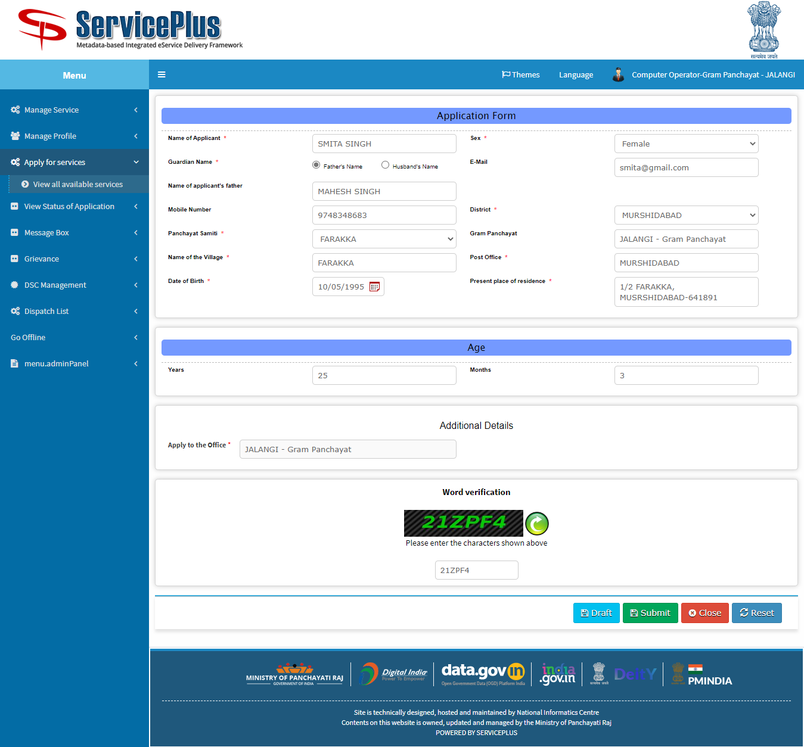

5. Screenshot of certificate

